# KrigMapPro Guide

This guide will go through how you (the user), will navigate through KrigMapPro.

## Opening the Application

If its your first time opening the application, it will take about 10-15 minutes for the app to open, due to a lot of python imports that needs to be unpacked.

Pressing the KrigMapPro.exe file and wait for a few seconds and you will see this interface:

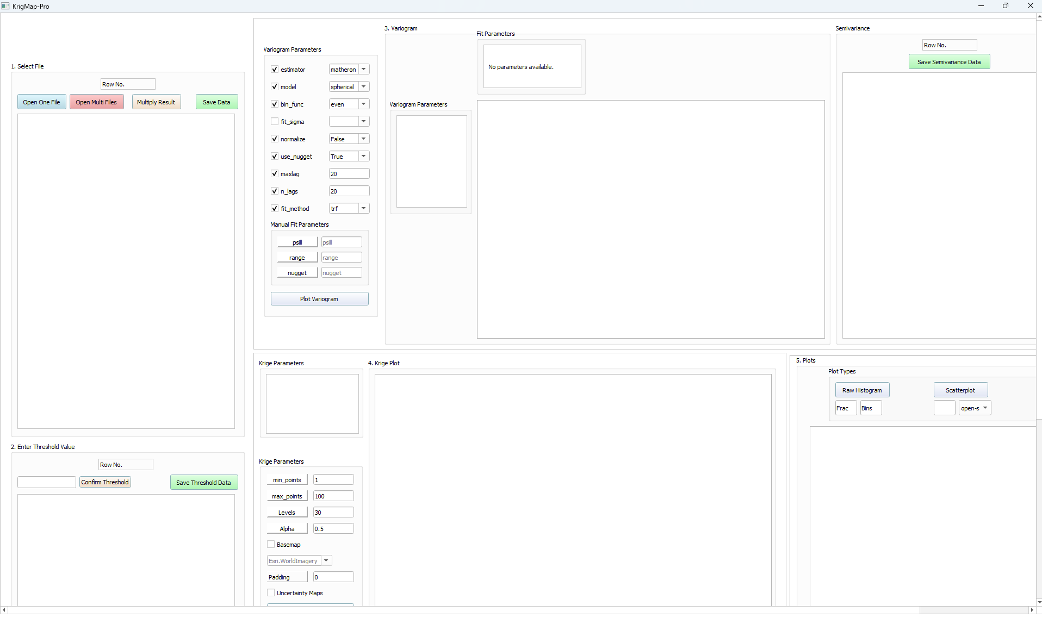

There are scroll bars in the right side and bottom of the interface, for you to see the whole interface( at the top right corner, click the middle icon for the scroll bars to appear).

5 widgets are present on the interface, they are numbered from 1-5:

1.Select File

2.Enter Threshold Value

3.Variogram

4. Krige Plot

5. Plots

## Select File to be loaded in

The first widget you need to interact with is 1.Select File.

You can open .xlsx, .xls,.csv files. So you have the option to open one file using ‘Open One File’ or opening multiple files using ‘Open Multi Files’, which the files can have the same column names or the files can have different column names, but same units.

If the file contains more than three columns, a window will pop up asking what is the Longitude, Latitude and Result columns.

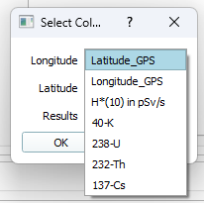

If you’d like to change the unit of the result column (e.g. converting the detectors unit of measuring radiation activity to your unit you’re familiar with), the Multiply Result button is used for this case.

Data that’s loaded in the 1.Select File can be saved as .txt, .csv and .xlsx file format

### Open One File

To open one file, press the Open One File button.

Click on file, and then press Open.

If file has three columns, it will load in to the 1.Select File widget.

If file contains more than three columns, the Select Columns window will pop up, asking you the columns to be loaded in.

### Open Multiple Files

To open multiple files, press the Open Multi Files button.

A window Select Files pops up. The interface is shown below:

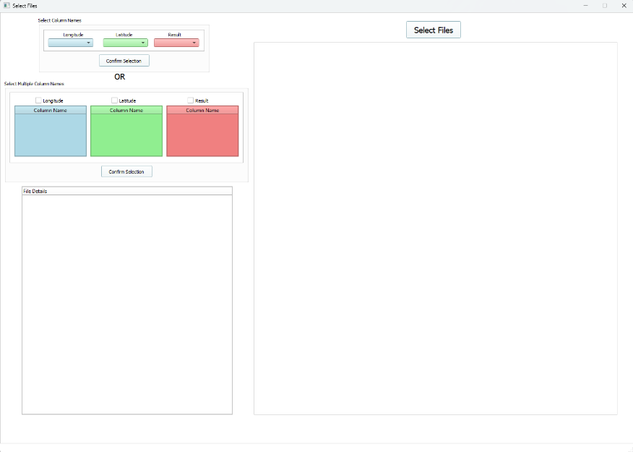

There are two widgets to focus on.

There is Select Column Names. Use this when you want to open files that has the same column names and same units.

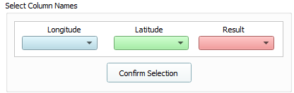

The Select Multiple Column Names is used when you want to open files that has the different column names and same units.

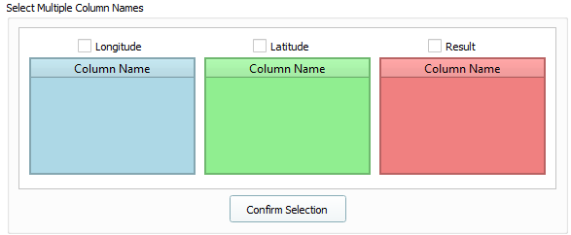

#### Select Column Names

Use this widget when you’re loading files with same column names (e.g. you have 5 files and they all contains columns lon, lat & dose).

1. Press the Open Multi Files button in the 1.Select File Widget.



1. Select Files Window pops up and you see this.

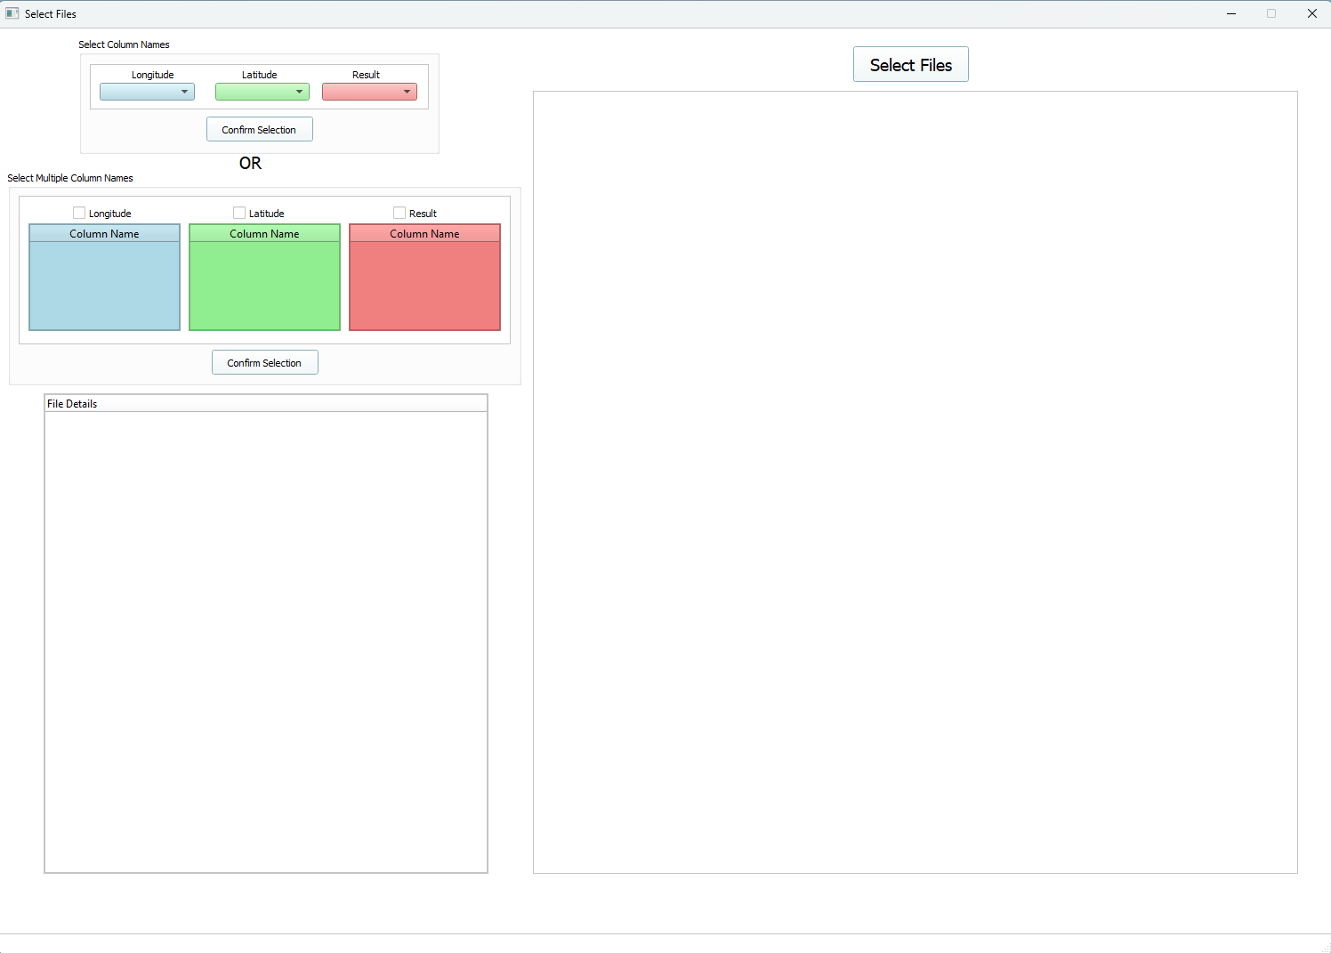

1. Press the Select Files button.



4.You will see your file directory and pick your files. Press Open when you’re done picking. You can go back to this file directory by pressing Select Files again. If you want to remove files, then you need to close Select Files window and start over in selecting your files.

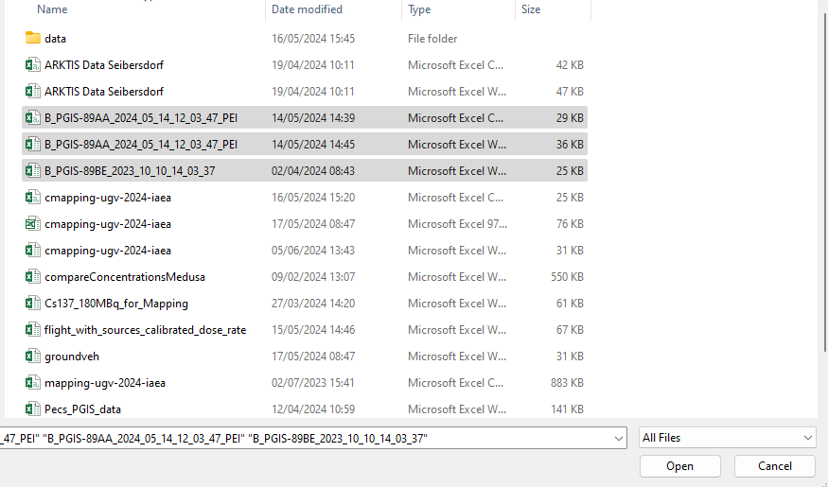

1. Your files are loaded in as a table format (right side of Select Files window) and the file name and associated column names are loaded in as a treeview format (left side of Select Files window).

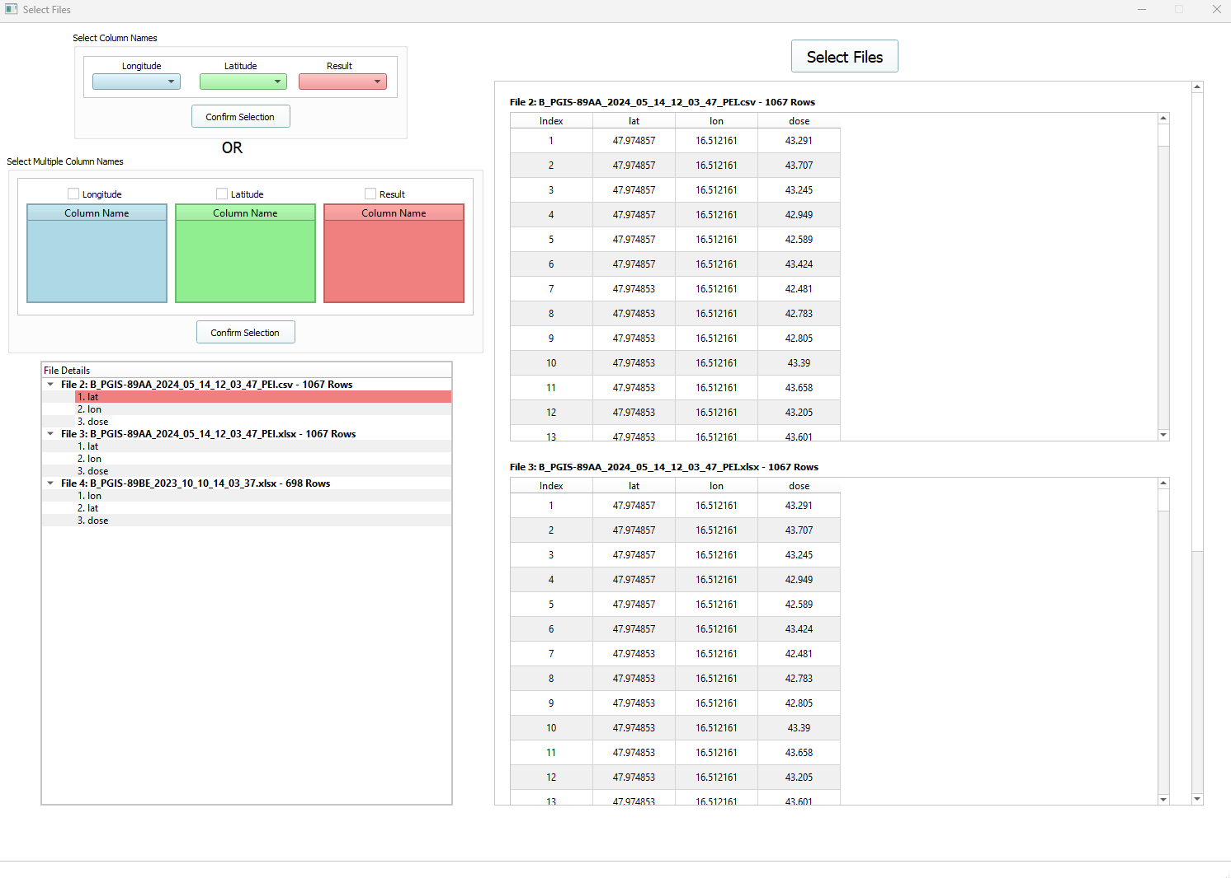

1. Go to this widget Select Column Names.

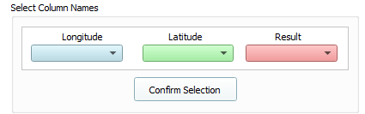

1. Press the first drop-down box Longitude. Select the column name that contains the longitude data. In this test case, it’s the column name lon.

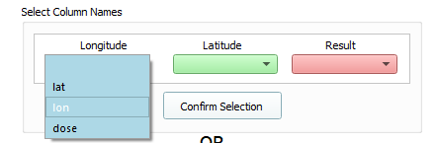

1. Now the lon columns are highlighted blue in the treeview and tables. Ignore the red highlight.

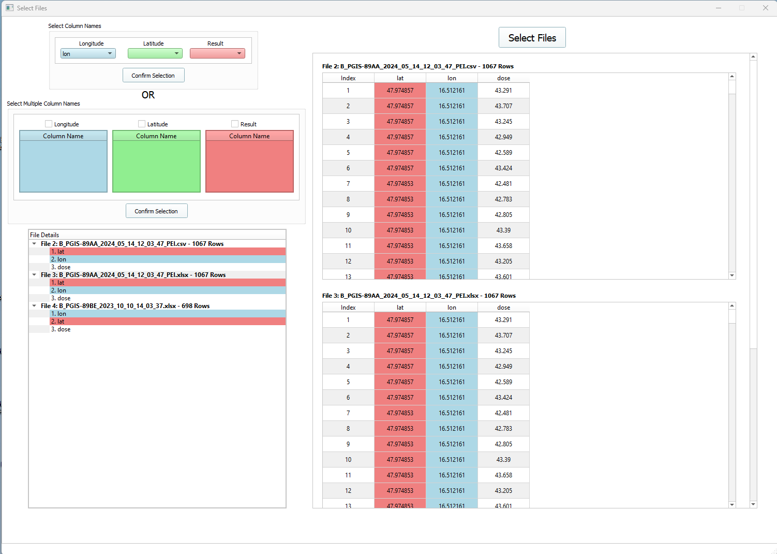

1. Repeat step 6. Now for your latitude and result data.

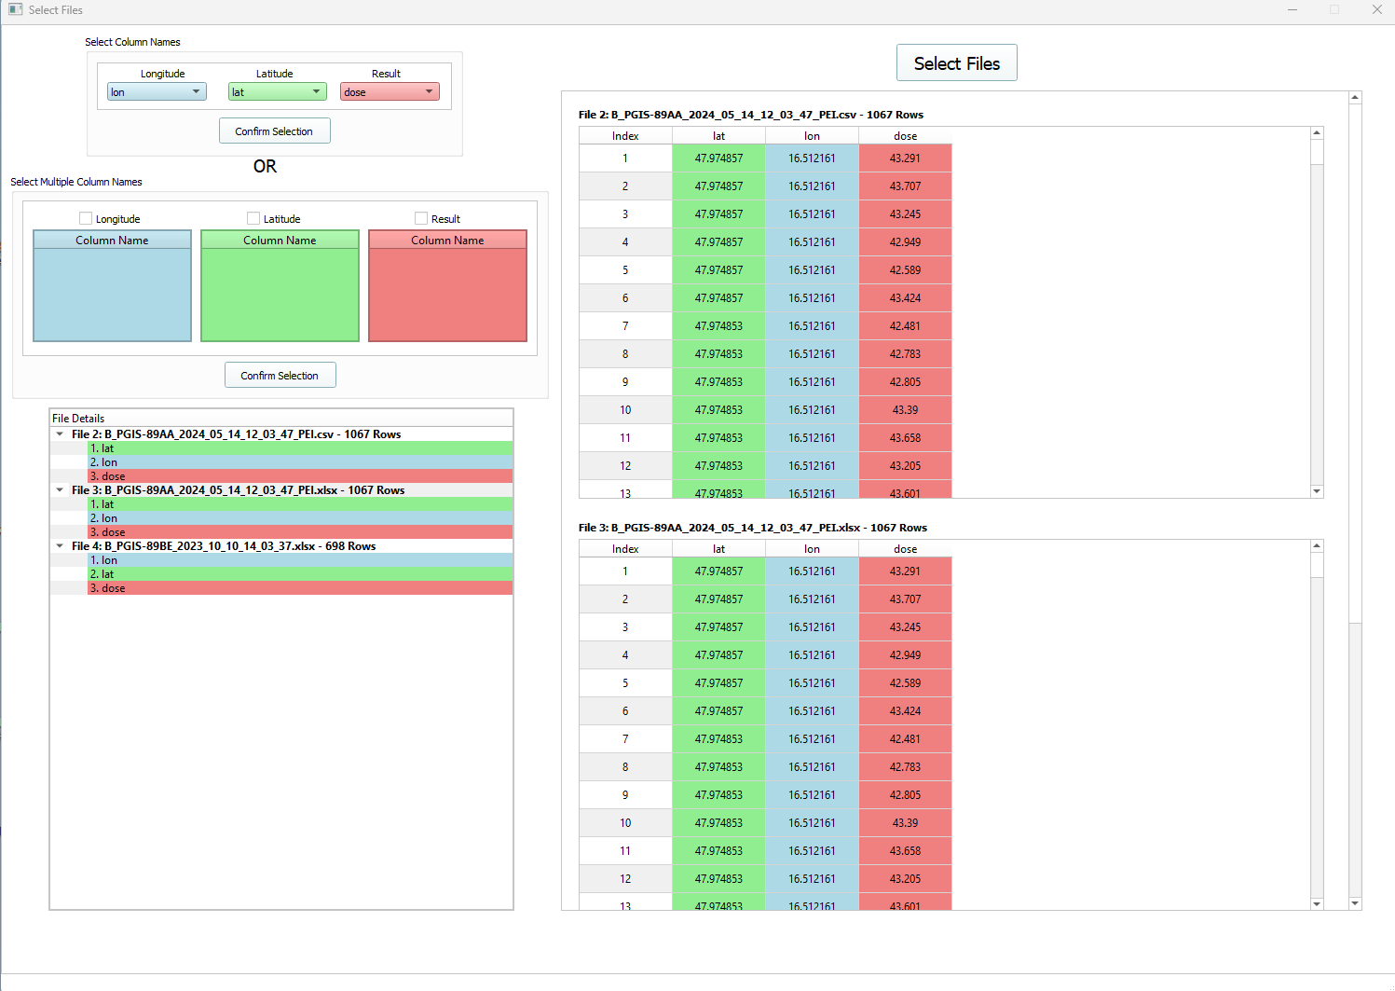

1. Satisfied with what you picked for your data. Press the Confirm Selection button.

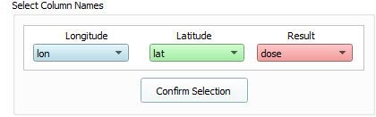

1. Selected Data window pops up with your selected data. Press the button Confirm.

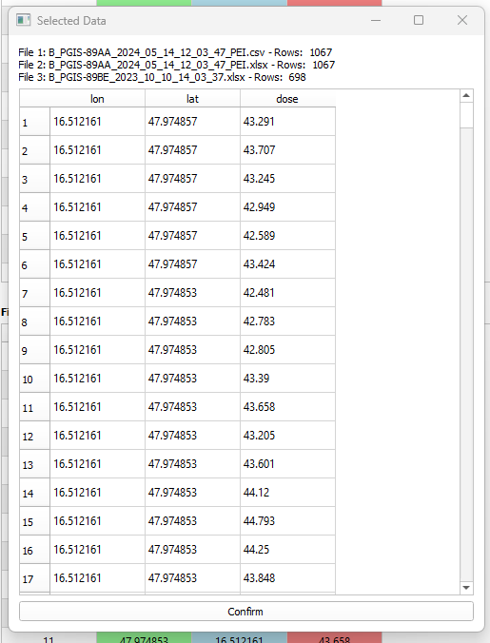

1. After pressing Confirm, then you get this window. Feel free to close it and go back to the Main window KrigMapPro.

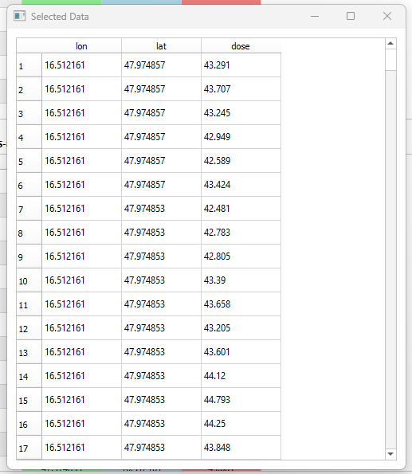

1. The data is in the 1.Select File widget.

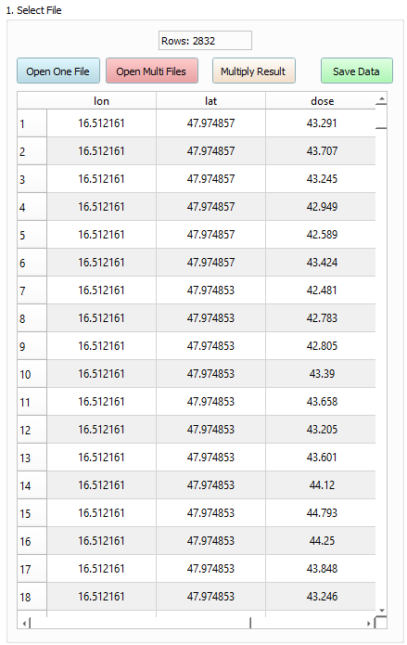

#### Select Multiple Column Names

Use this widget when you’re loading files with different column names (e.g. you have 5 files and they all contains different names for their longitude, latitude and result data).

1. Press the Open Multi Files button in 1.Select File widget.



1. Select Files window pops up.

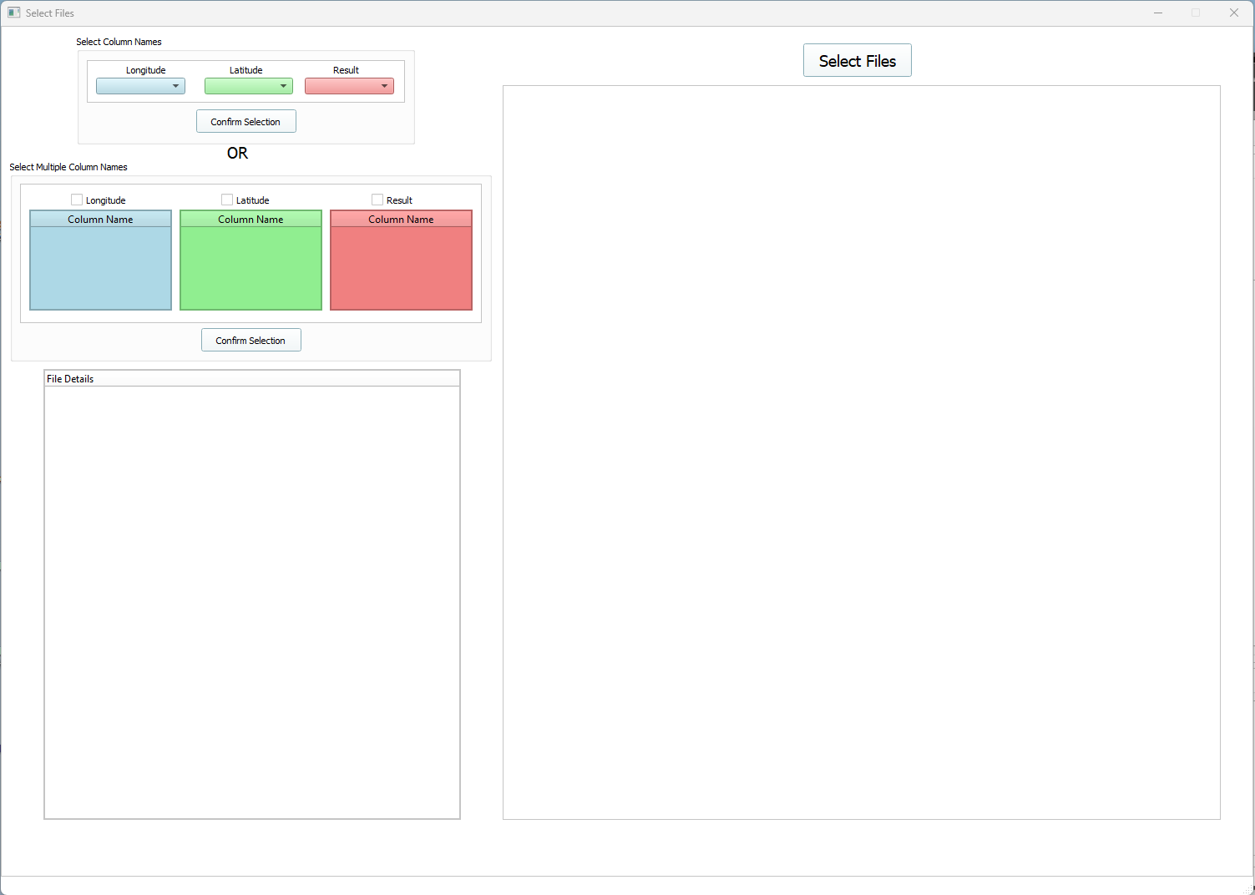

1. Just like Steps 3-5 in Select Column Names. Select your files and the files will be loaded in to the Select File window.

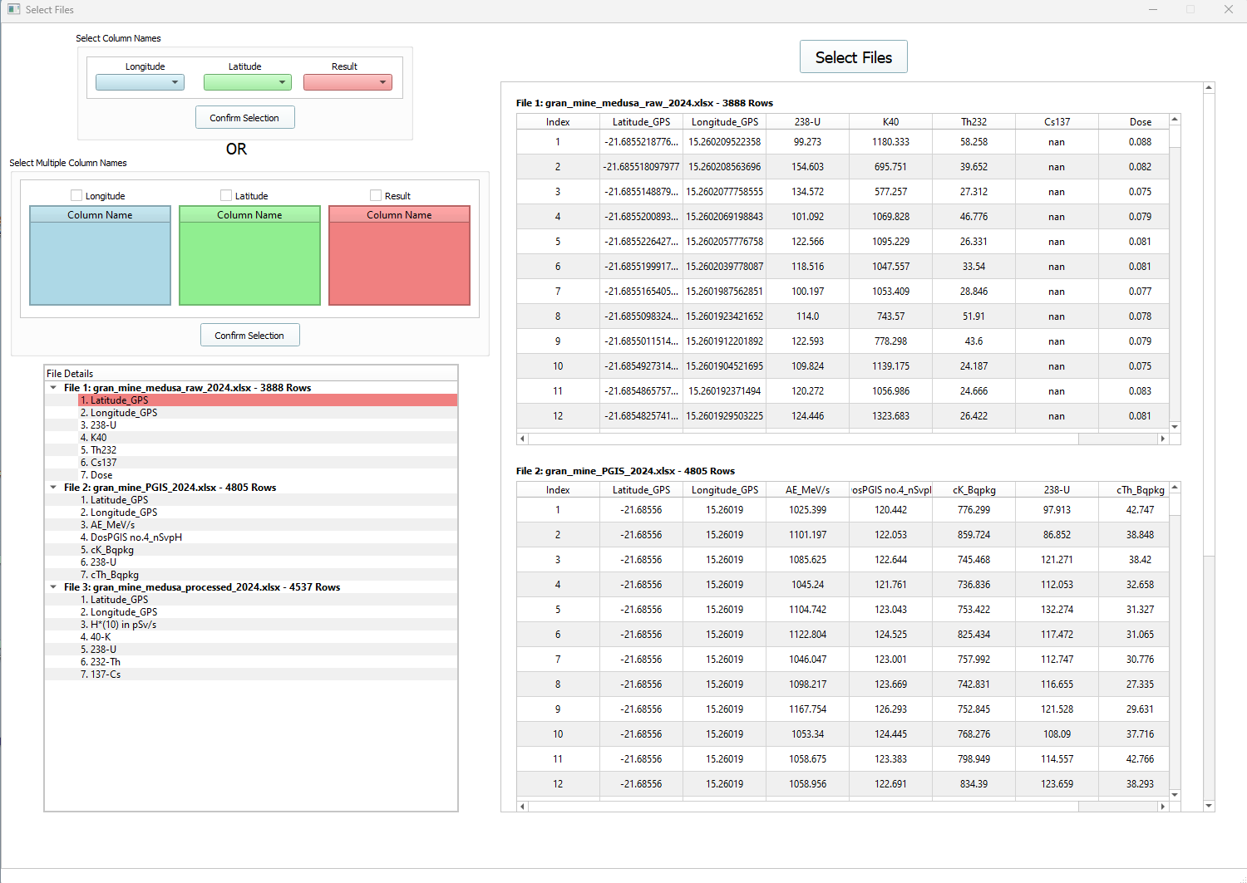

1. Focus on Select Multiple Column Names widget.

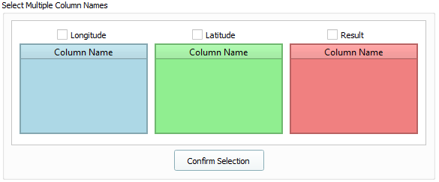

1. Tick the Longitude checkbox and to choose your Longitude data, go to the treeview. Click on the column name that is a longitude data.

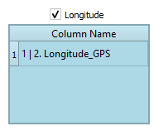

1. The column name is highlighted blue in the treeview and table. The highlight is removed when the column name in treeview is clicked on again. So its just clicking on the column names in the treeview that are considered the Longitude data.

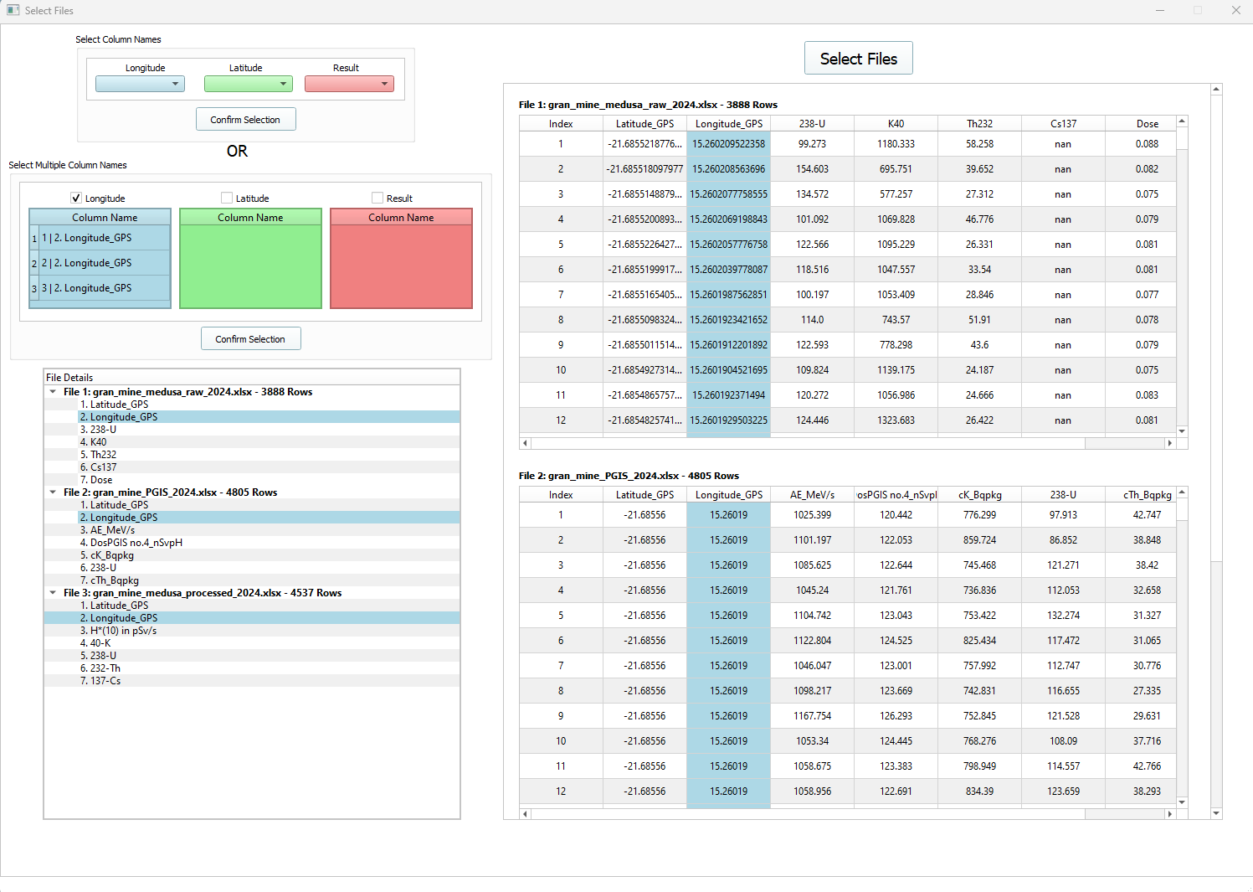

1. Repeat the step 5 but now with Latitude and Results. Essentially tick the Latitude box, go to treeview, then click on the column names that’s considered Latitude. Do this again for Results.

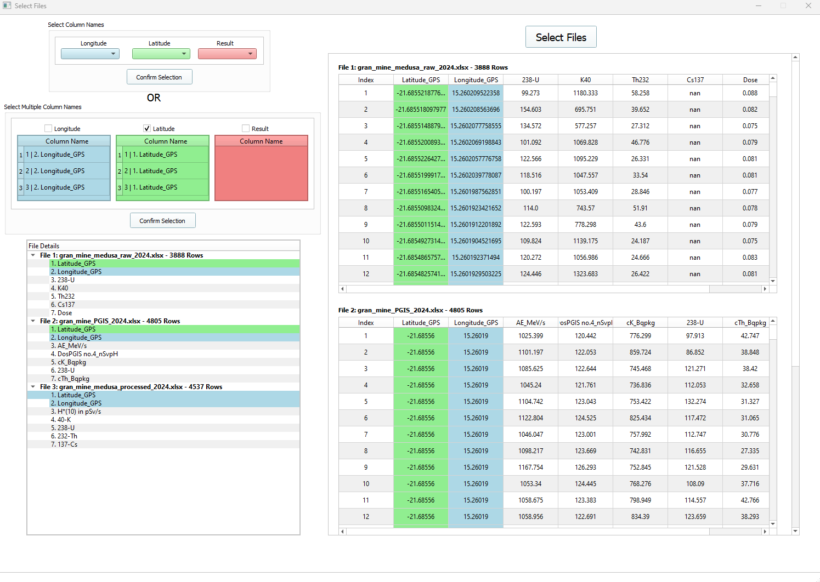

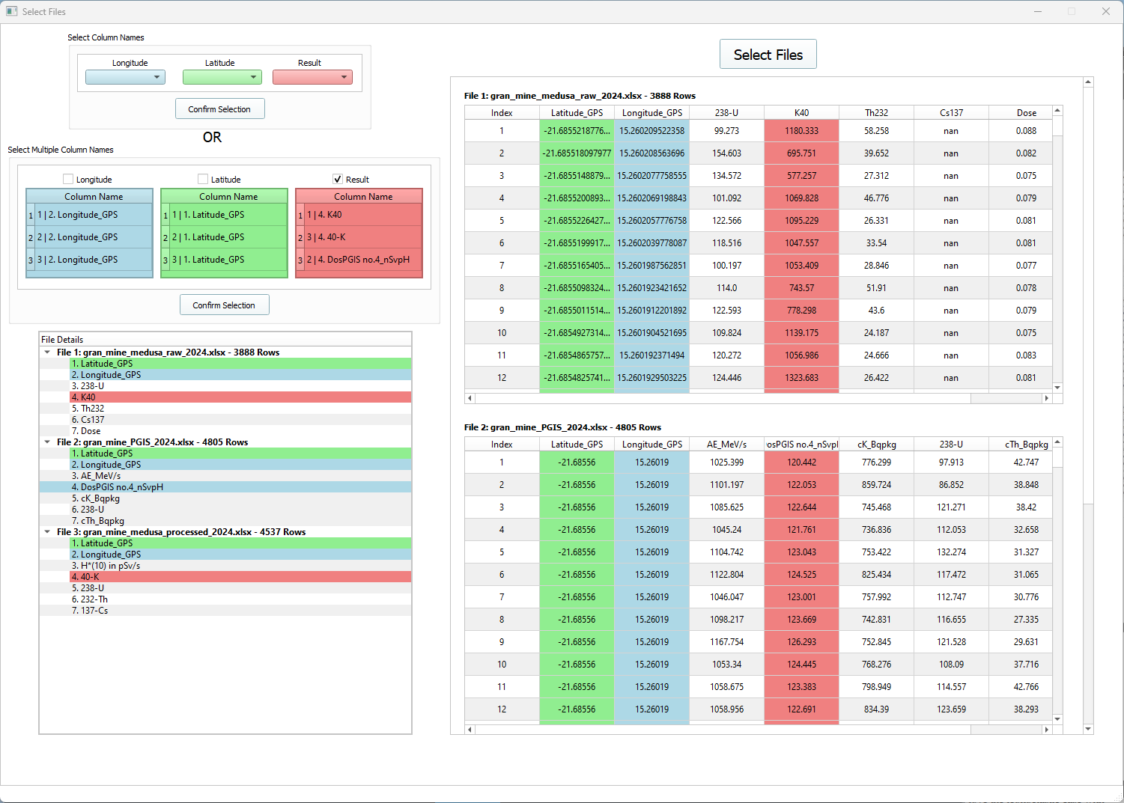

1. Press Confirm Selection button when done selecting.

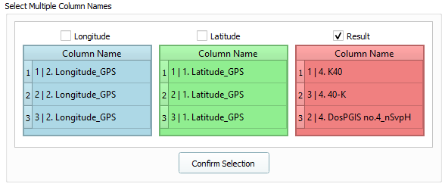

1. Data Preview window pops up showing the chosen columns. You have the choice to add +, subtract - , multiply * or divide / a number to a certain Result Column. Type in your symbol and number in the correct box. Then press Apply. You will get a column Changed Result (appearing beside Result column), which contains the new column values. Press confirm when happy with the data.

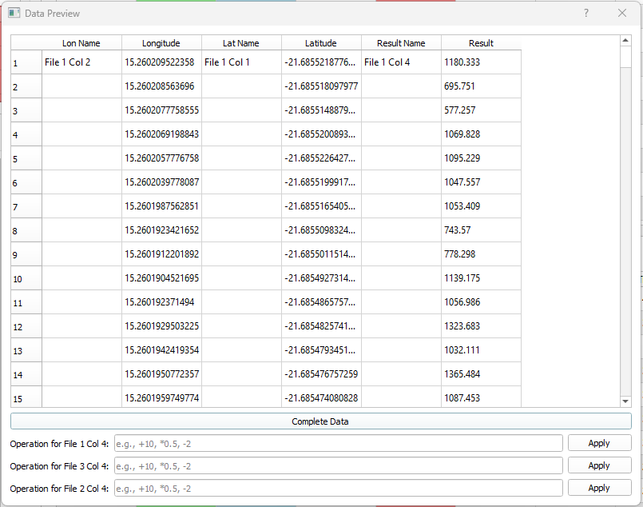

1. Complete Data View pops up after pressing Complete Data. Press Save Data.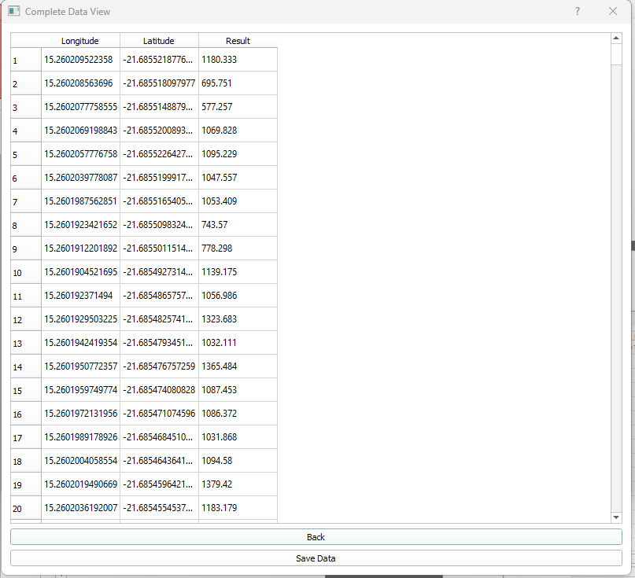
2. Save the data in either a .xlsx, .xls or .csv file.

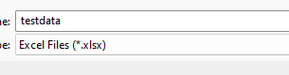

1. Save successful window pops up and Press Ok.

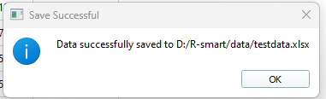

12.Go back to the 1.Select File widget and press Open One File button. Select your saved file and it will be loaded to the 1.Select File widget.

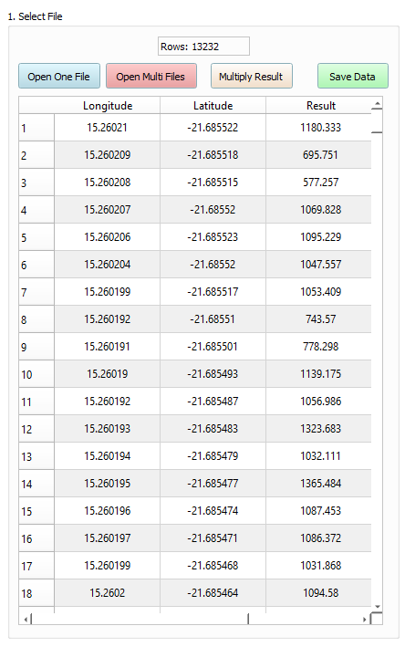

## Enter Threshold Value

1. Typing 0 shows the original data from 1.Select File.

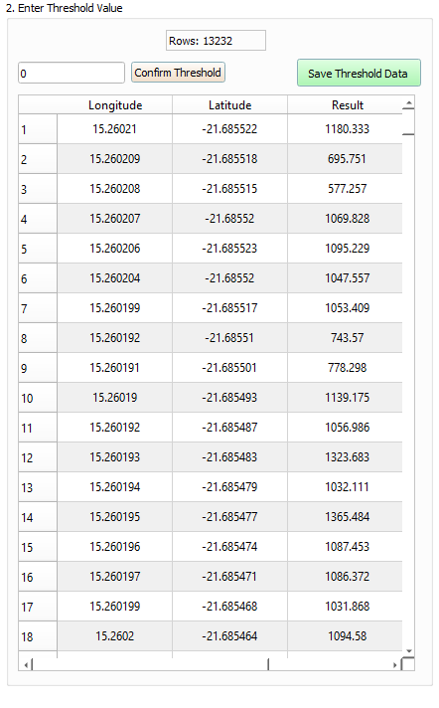

1. Typing any value above 0, may filter the data. In this a value 0.04 doesn’t filter out data.

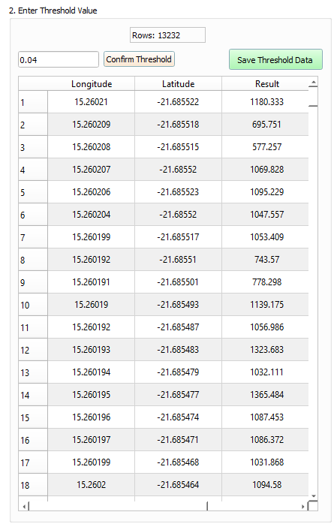

3. A threshold value of 1, filters out data. When happy with this, move to next section , which is creating the variogram.

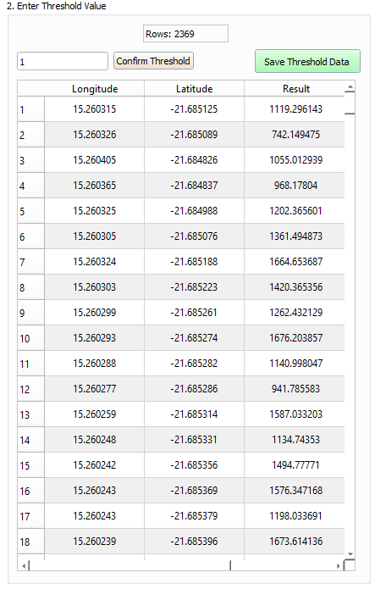

## Creating your Variogram/Semivariogram

1. Now that you have your threshold data, all to do now is to press Plot Variogram. The parameters to tick are the default parameters used to create a variogram. To know more about the parameters, check the scikit-gstat [Variogram Class](https://scikit-gstat.readthedocs.io/en/latest/reference/variogram.html) .

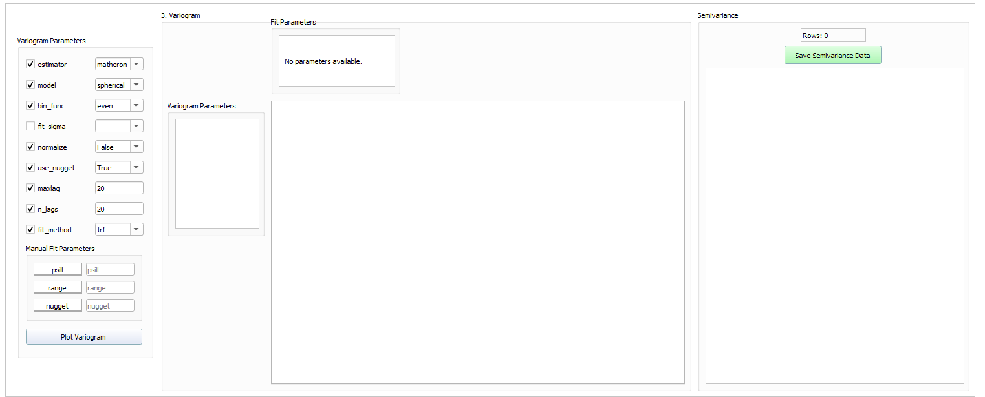

1. After pressing Plot Variogram, you will see the variogram in the tab (in this case, Variogram Plot 1). The variogram parameters that were used to create the variogram are in the left of the tab. The fit parameters are at the top of the tab. And to the right of the tab, the pair-points(np), lags & semivariance are shown.

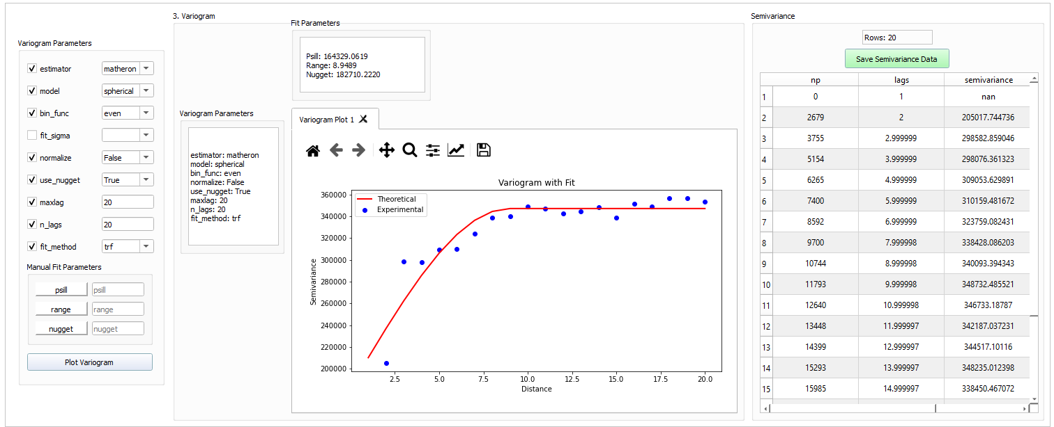

1. There is the option to type in your own fit parameters. Pick the manual option in fit_method and type your values in the Manual Fit parameters entry boxes.

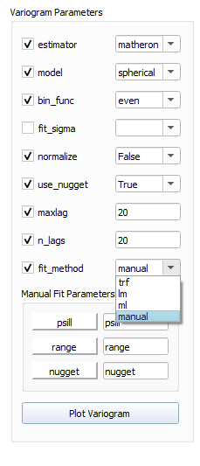

1. Here is a variogram created using manual option for fit_method. There’s the navigation toolbar (highlighted red box) which enables you to zoom in, pan through the graph, change the axis titles and limits, and change the display of graph.

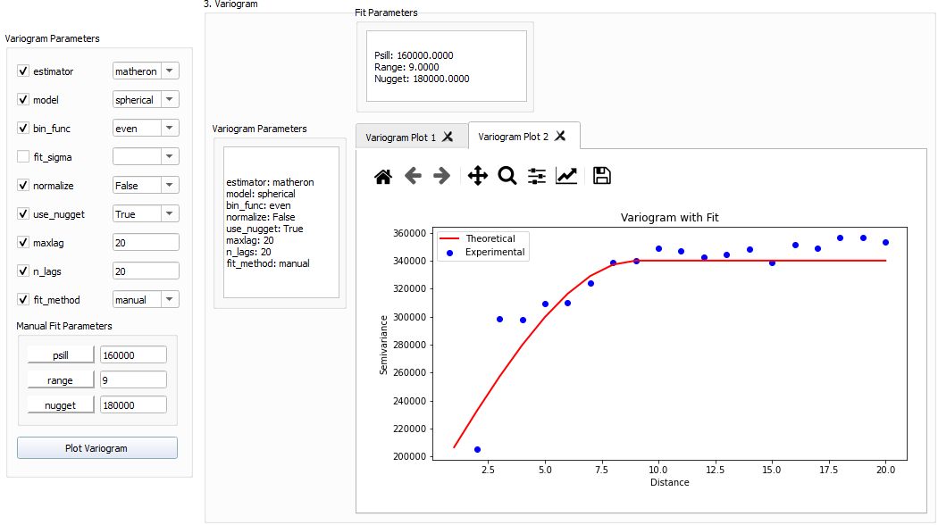

## Creating your Krige Plot

1. Before creating your Krige plot, make sure that the variogram that you want to use for Kriging is the active variogram tab. So just click on the tab (e.g. you want to use Variogram Plot 2, then click on Variogram Plot 2 tab). To know more of the Krige Parameters, go to [Sci-Kit Gstat OrdinaryKriging Class](https://scikit-gstat.readthedocs.io/en/latest/reference/kriging.html) .

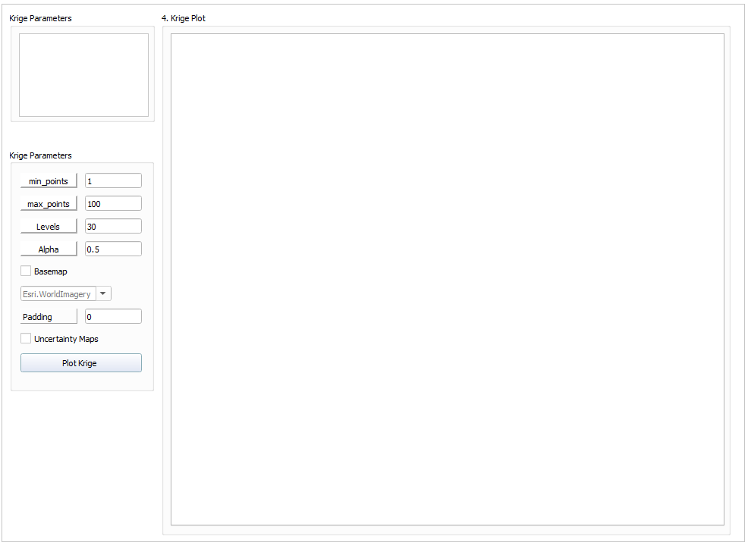

1. There’s an option to add a satellite map underneath the Krige plot. Tick Basemap and choose your option. To see like a spaceman’s view of the earth, use Esri.WorldImagery option. Sometimes the satellite map won’t load so you need to increase the area of view, so try with 0.1 value and increase in 0.1 increments until the satellite map loads in.

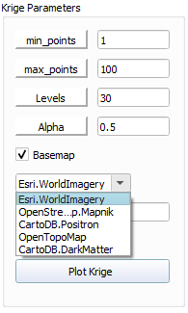

1. Tick the Uncertainty Maps option if you want to see the uncertainty associated with the Krige calculations.

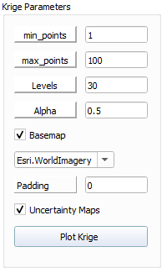

1. Here is a Krige Plot with the Basemap Esri.WorldImagery. and using default Krige parameters.

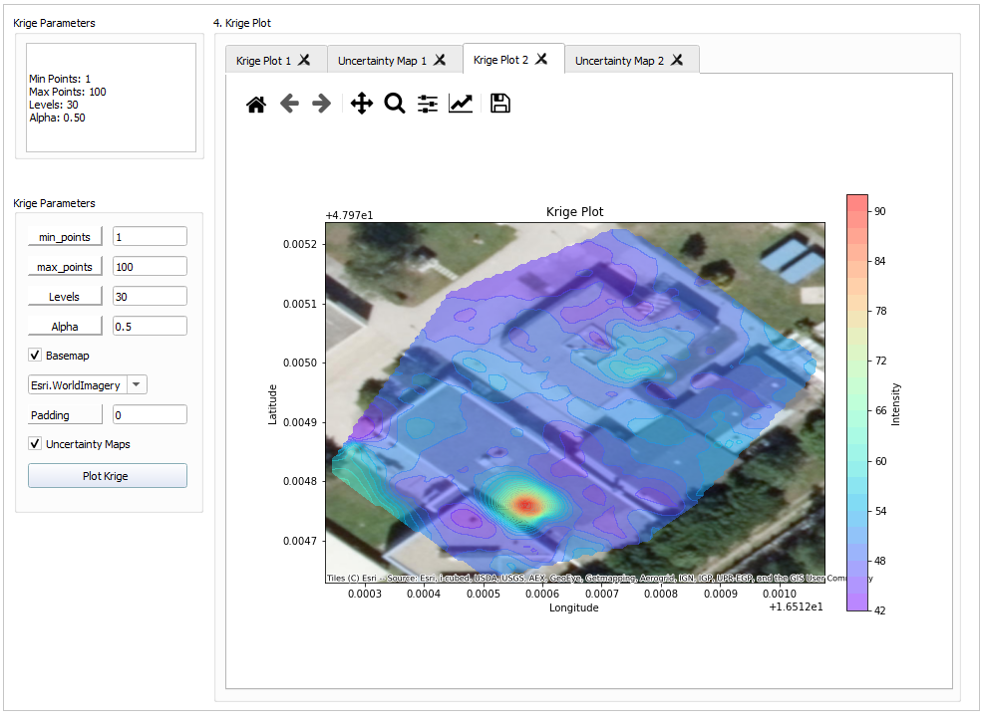

1. This is the uncertainty map associated with the Krige plot.

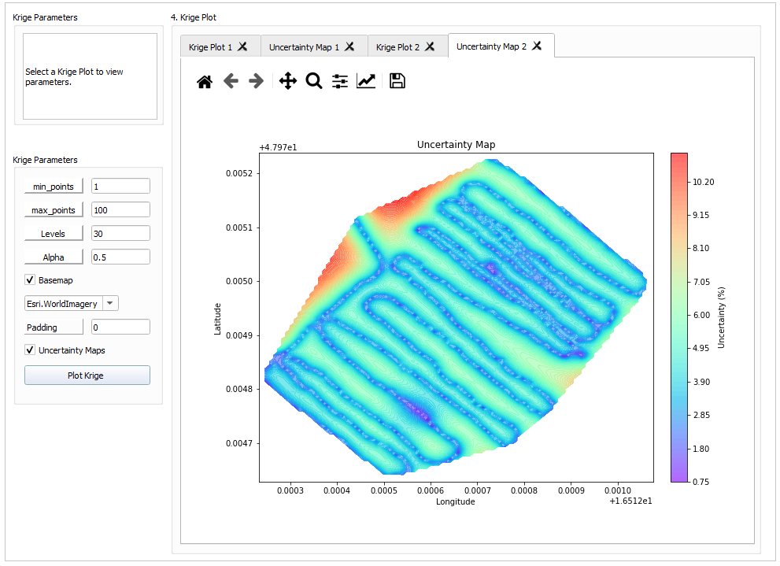

### Krige Plot Bug – Esri.WorldImagery Basemap not appearing

1. Your data may not encompass a wide area so the basemap won’t appear. Due to basemap don’t have tiles at that certain zoom level. See how the background of the krige plot is grey and not colourful.

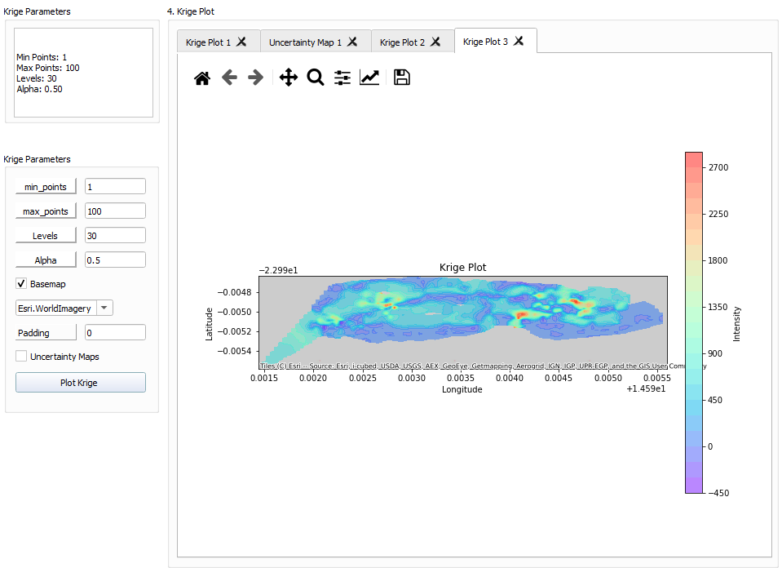

1. To see Esri.WorldImagery basemap, use the Padding option. This is to ‘zoom out’ the Krige Plot so the basemap tiles can appear.

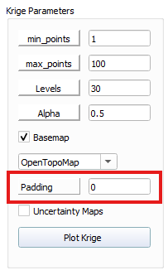

1. 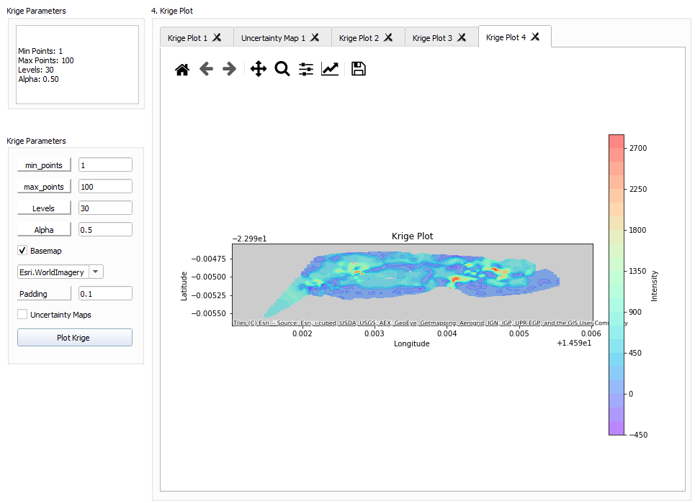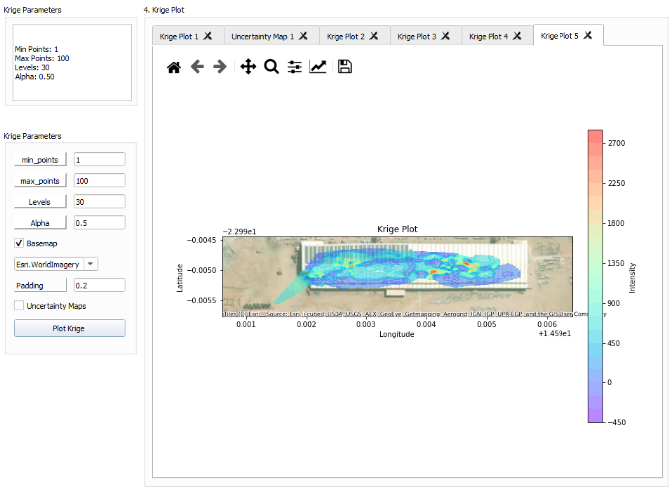Start with Padding value 0.1, and go in 0.1 increments until you see the basemap(you can go in larger increments if you feel 0.1 increments takes too much time).
2. Padding value of 0.2 made the Esri.WorldImagery basemap to appear in this case.
3. 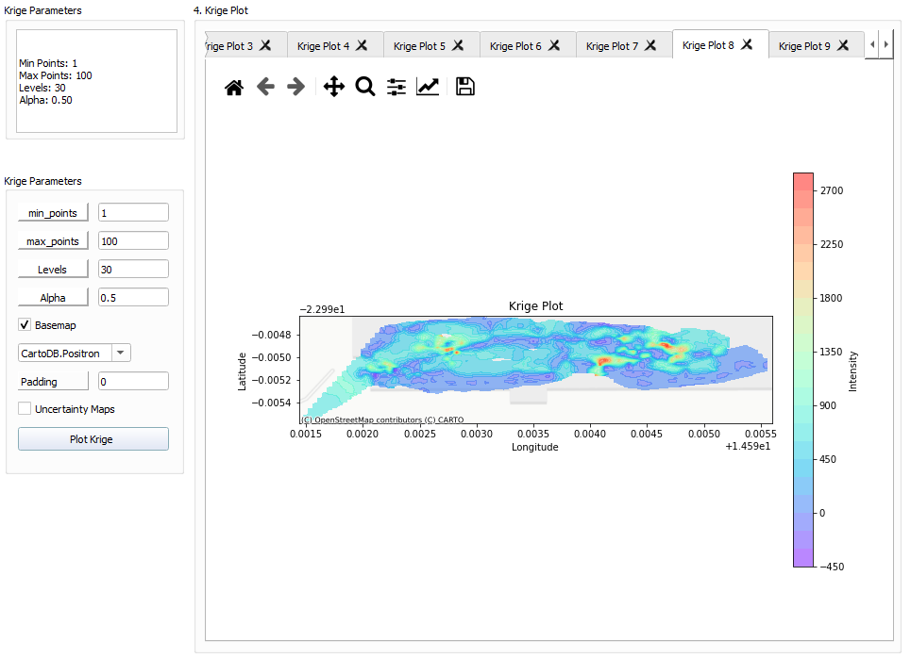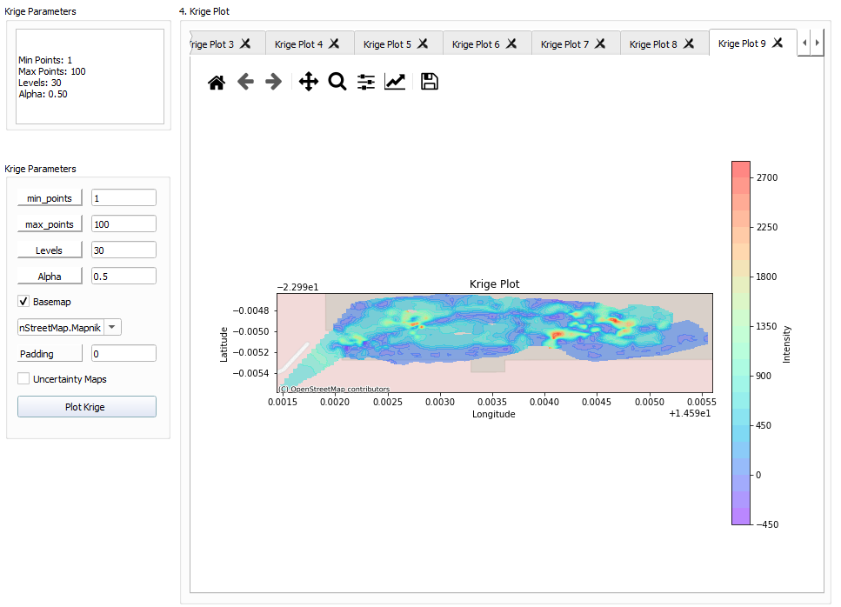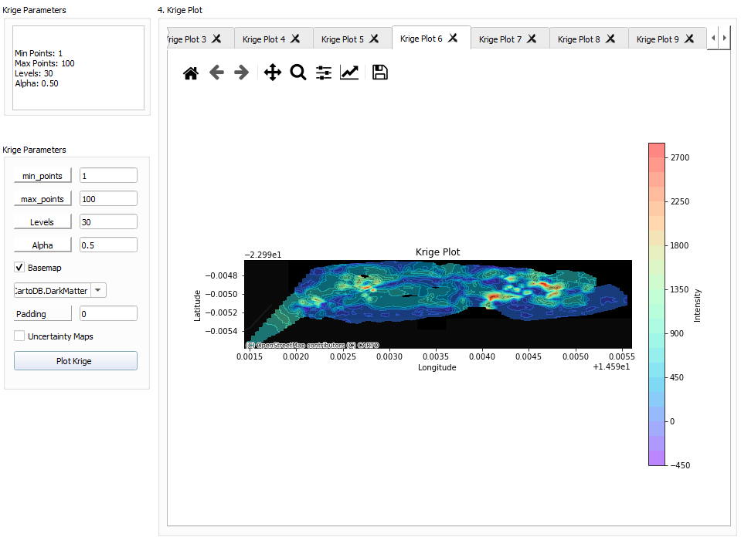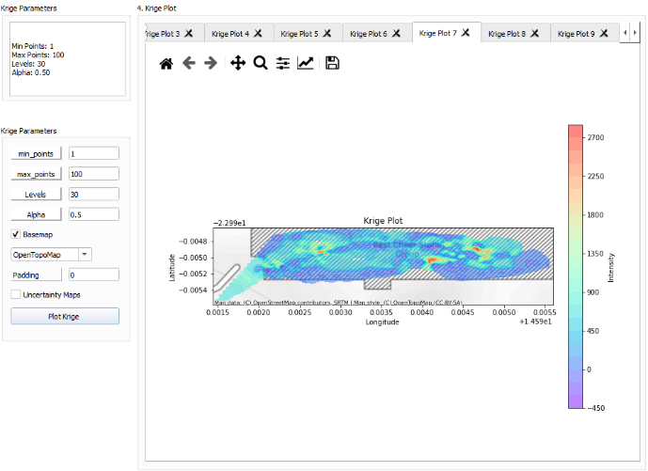There are other Basemap options to use other than Esri.WorldImagery and you don’t need Padding option for the other options. That’s because they don’t provide as much detail as Esri.WorldImagery basemap.

## Additional Plots

1. 5.Plots widget gives you an option to see your data as a histogram, scatterplot and pairplot.

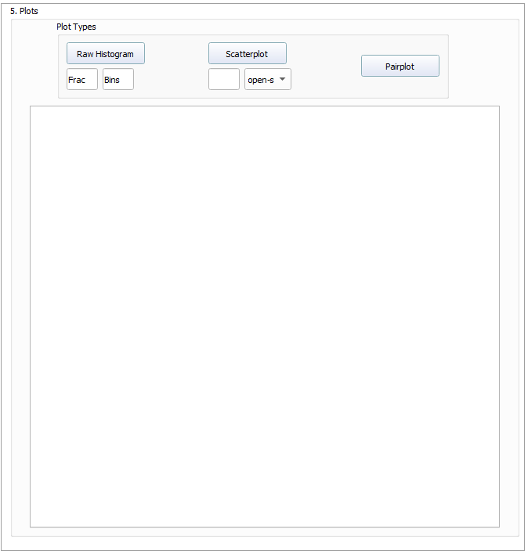

### Histogram

1. A Frac (fraction) and Bins number must be inputted before pressing Raw Histogram button. Entering 0 for both, you get the full data. The fraction value has to be given in decimal number.

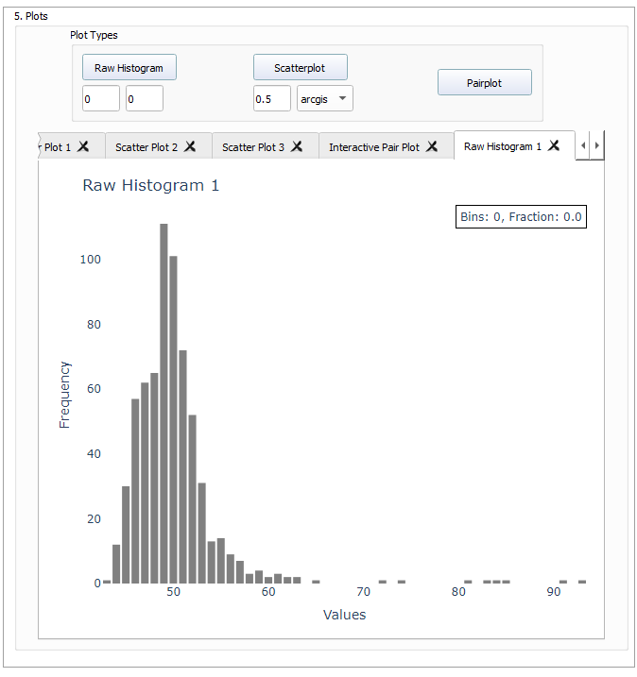

### Scatterplot

1. Scatterplot can be created without a Frac(fraction) number. You have the option to choose open-street-map or arcgis as your satellite map.

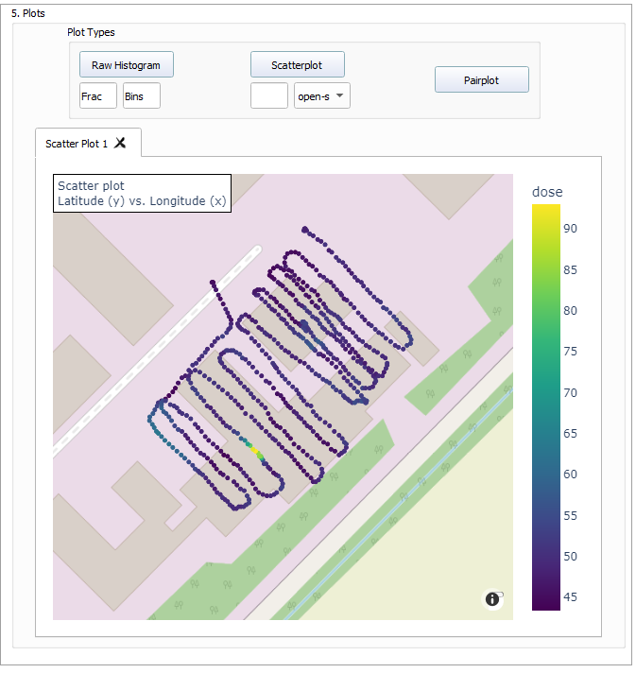

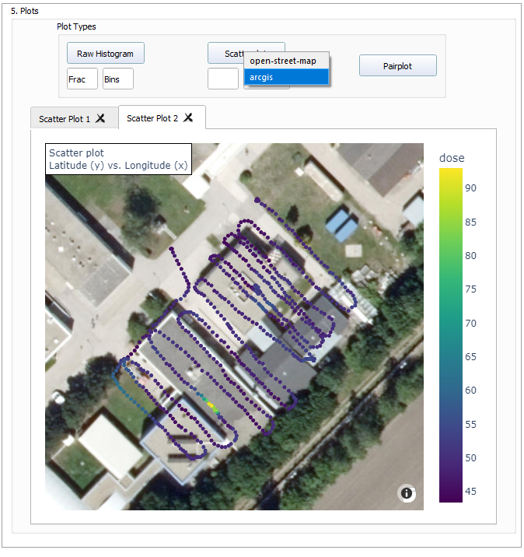

1. This is a scatterplot with a frac 0.5 and using arcgis satellite map.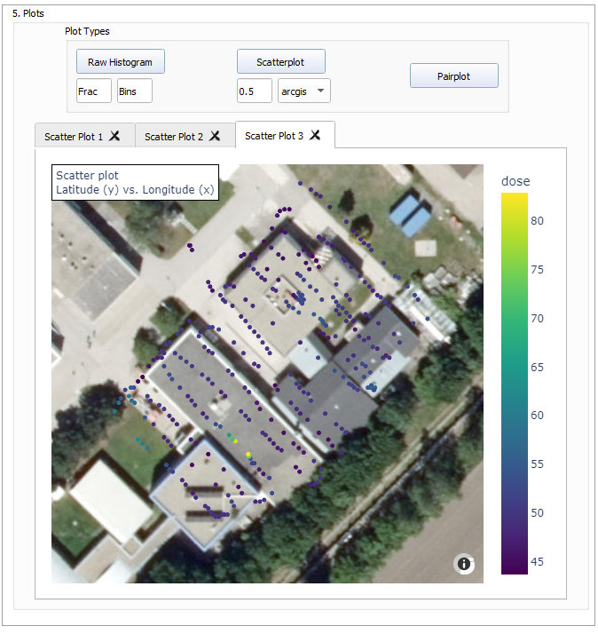

### Pairplot

1. Pairplot can be created by pressing Pairplot.

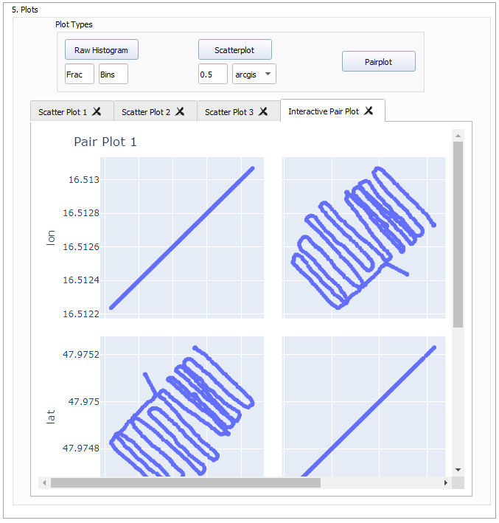

This is the end of the guide ☺